Practical-1
2520030274
CH.Meghanadh Sai Reddy
S-7
C file-(program)

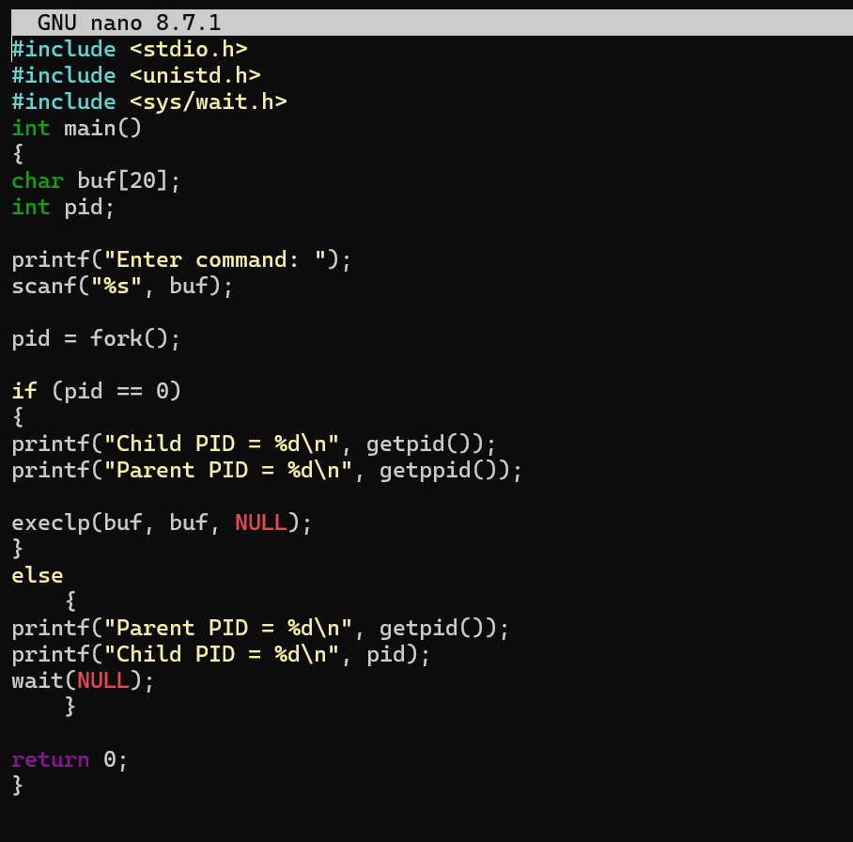

Output:
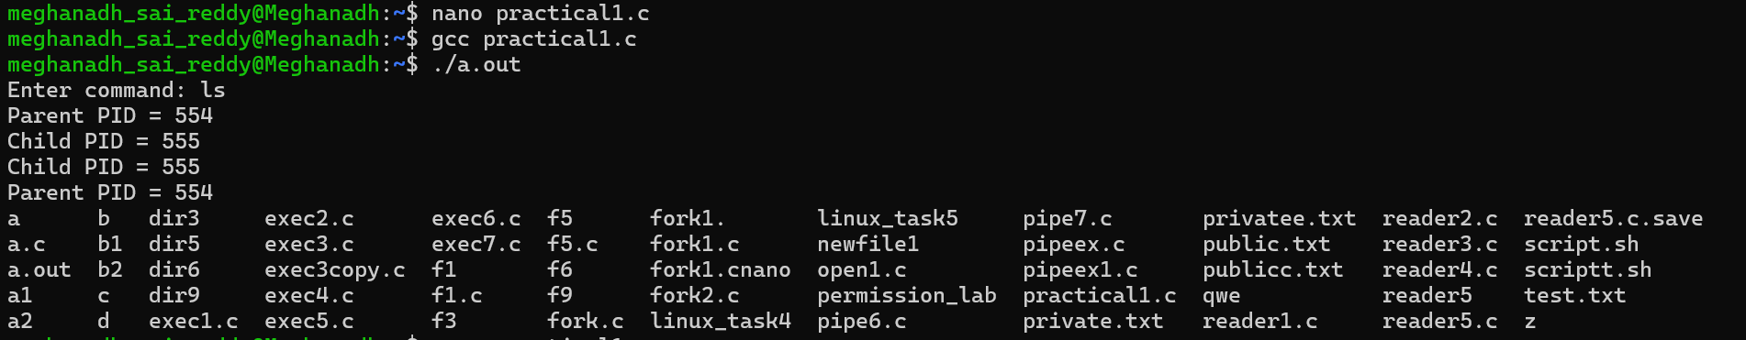

Lscpu output:
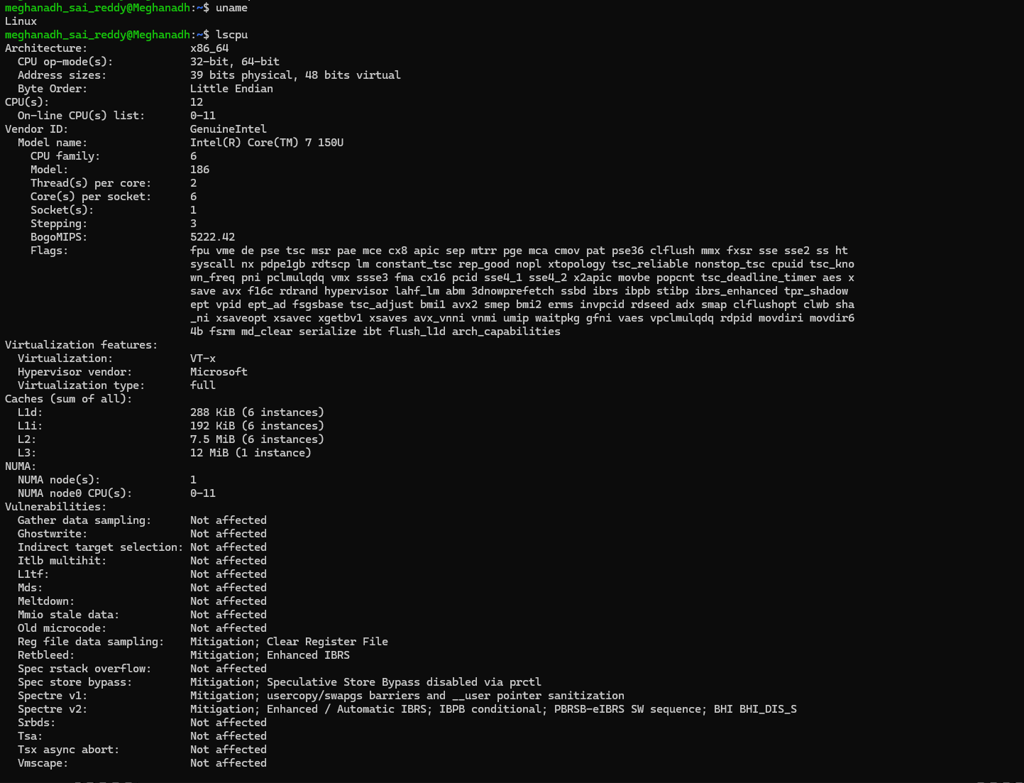
Lsblk output:

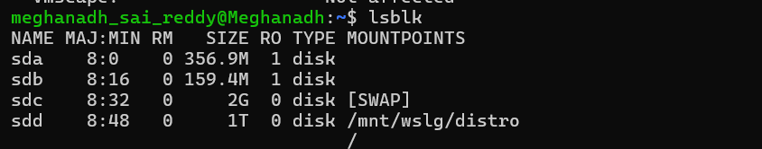
Ps output:
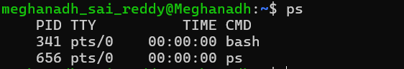
Top output:
